**NAMRATHA S**

**07/11/2024**

**FEYNN Labs: Project 2**

Real World Market Segmentation (EV Market Segmentation)

1. Explain how and which ML model (algorithm) helped you in 2nd Project?

2. Elaborate on the final conclusion & insights gained from the research/analysis work.

3. How will you improve upon the Market Segmentation Project given additional time & some budget to purchase data? (in terms of Datasets collection - name what columns points you will search for & what additional ML models you would like to try)

4. What is the estimated Market Size for your Market Domain (non-segmented) in Numbers?

5. Name top 4 Variables/features which can be used to create most optimal Market Segments for your Market Domain

For this solo project, titled Artificial Intelligence for identification of EV Segment , I put forth the idea of building an android and/or web application to identify the EV Segment by means of AI. In this study task, I, along worked on Market Segmentation (MS), and highlighted the key points theoretically and practically (using Python) that are vital to MS.

**Datasets used**

* car details v4.csv
* Electric_Vehicle_Population_Data.csv

**Dataset 1 -** car details v4.csv

* Vehicle Make
* Model
* Price
* Year
* Transmission
* fuel type

**Dataset 2** -Electric_Vehicle_Population_Data.csv

* Vehicle range
* Vehicle make
* Range
* Year
* City

**EDA DATASET 1**

* **EV Market Segmentation**

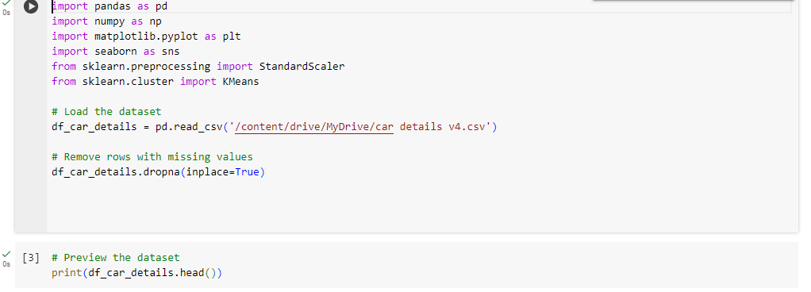

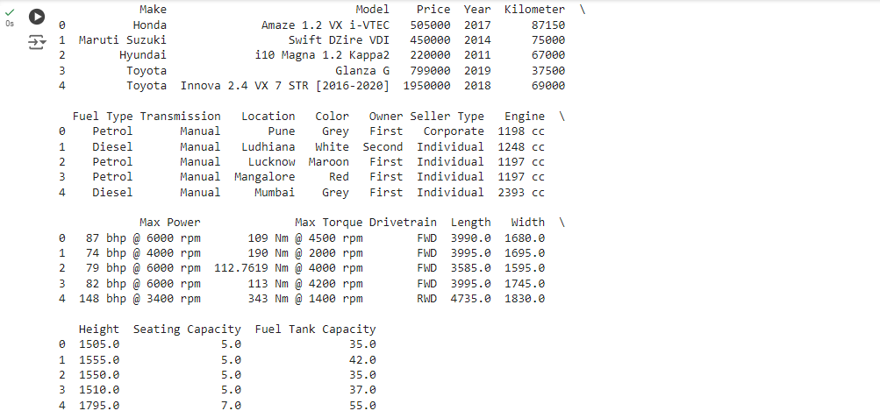

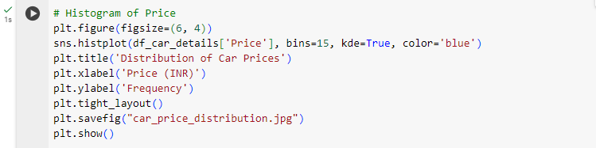

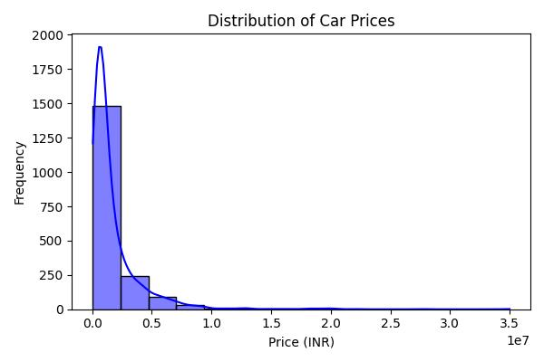

The histogram shows the distribution of car prices in a dataset. The x-axis represents the price in INR, and the y-axis represents the frequency of cars within each price range. The bars indicate the number of cars in each price bin, and the curve (if present) provides a smoother representation of the distribution. This visualization helps to understand the typical car prices in the dataset.

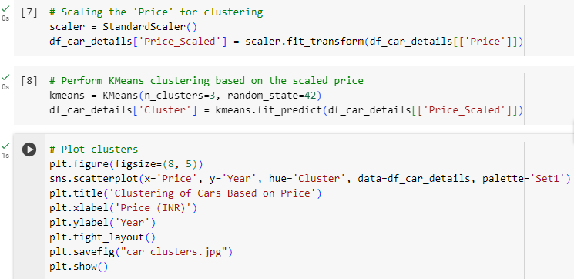

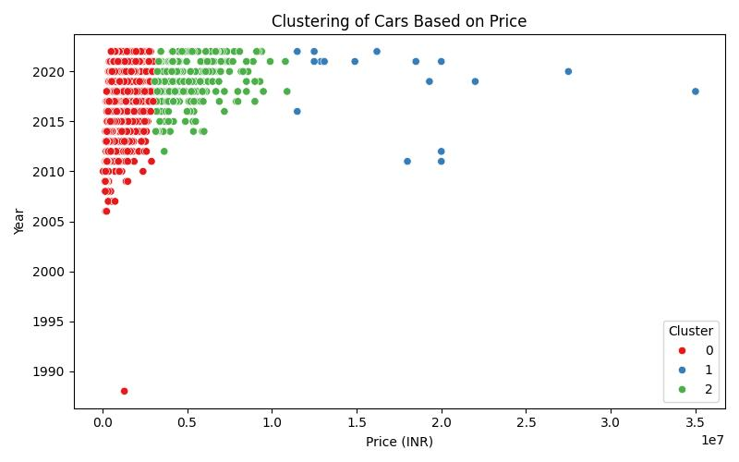

The scatterplot visualizes how cars are grouped based on their price and year. The x-axis represents the price in INR, and the y-axis represents the year. The points are colored according to their cluster, showing the relationship between these two variables within each cluster.

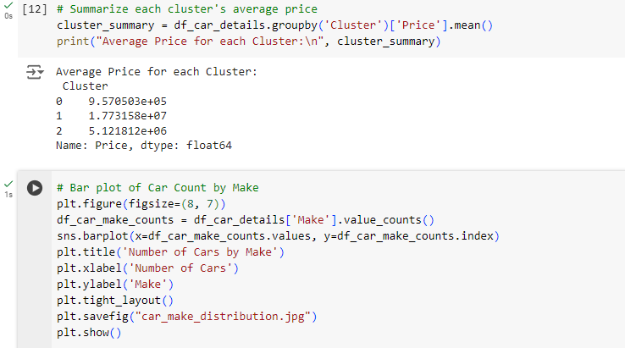

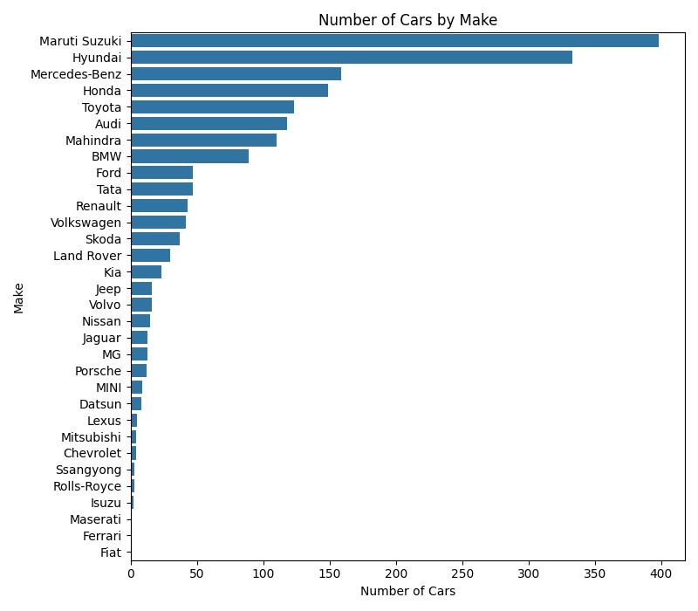

The bar graph shows the number of cars for each car made. The height of each bar represents the number of cars from a particular make, allowing for easy comparison of car popularity.

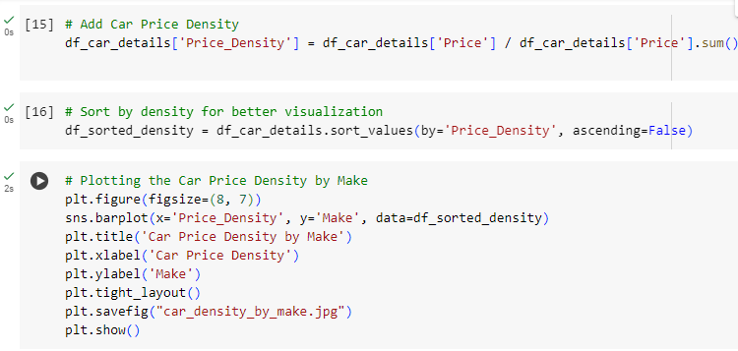

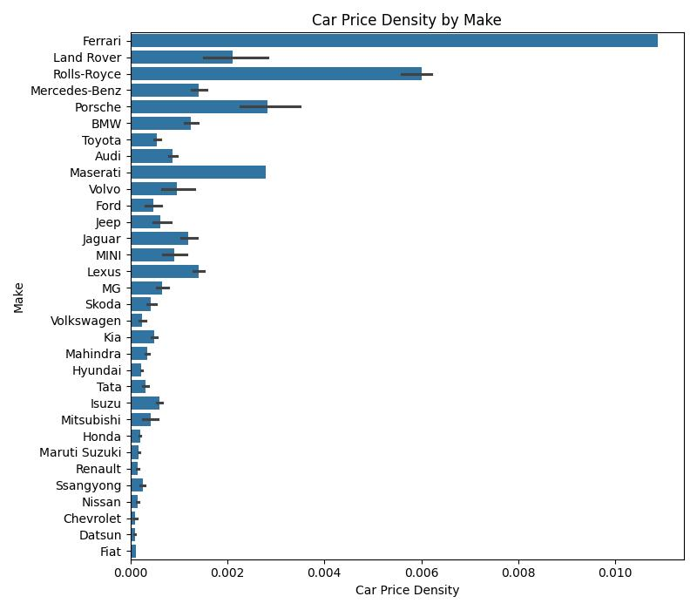

The bar graph shows the price density of cars for different car makers. The height of each bar represents the average price of cars from a particular make, allowing for easy comparison of car prices relative to their availability.

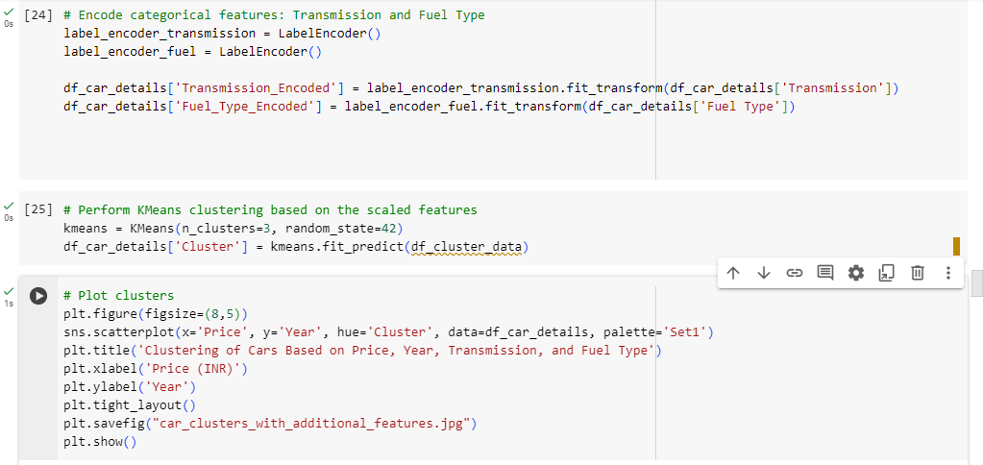

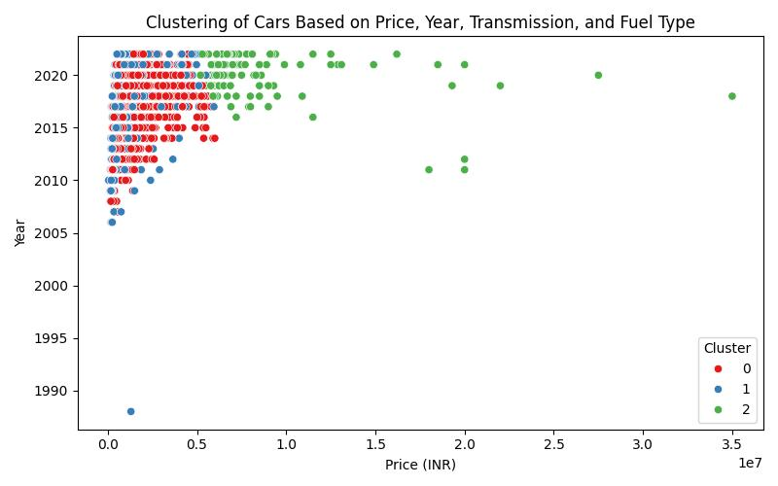

The scatterplot visualizes how cars are grouped based on price, year, transmission, and fuel type. The x-axis represents the price in INR, and the y-axis represents the year. The points are colored according to their cluster, showing the relationship between these variables within each cluster.

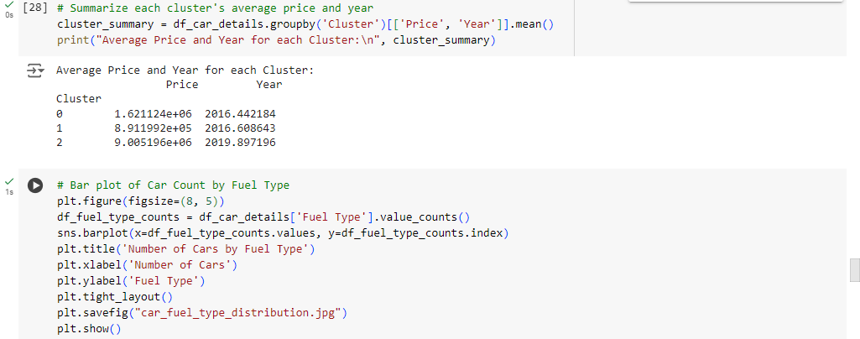

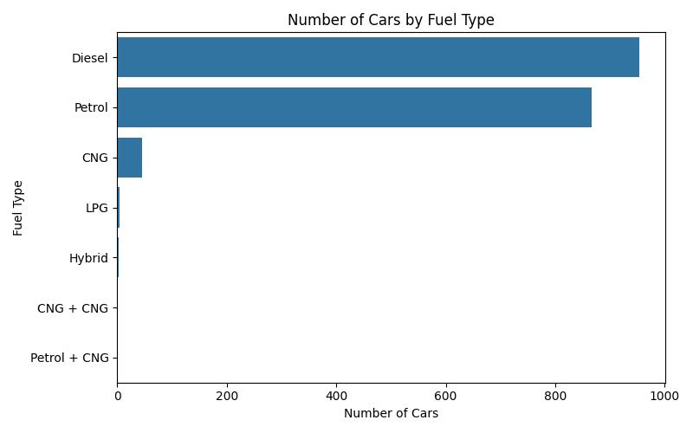

The bar graph shows the number of cars for each fuel type. The height of each bar represents the number of cars using a particular fuel type, allowing for easy comparison of fuel type popularity.

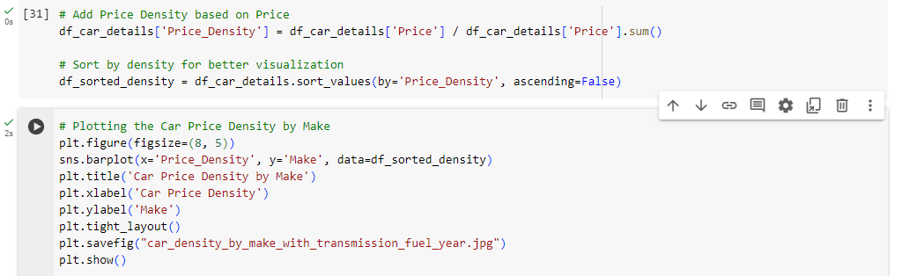

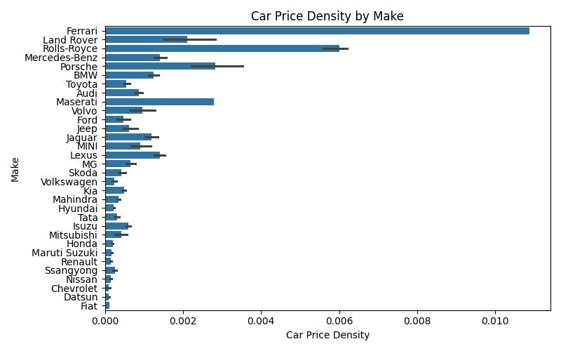

The bar graph shows the car price density for different car makers. The height of each bar represents the average price of cars from a particular make, allowing for easy comparison of car prices relative to their availability.

The dataset contains detailed information about electric vehicles, including their make, model, electric range, model year, and city of registration. The data is cleaned and analyzed to reveal trends such as the distribution of electric ranges, clustering of vehicles based on electric range, and the frequency of electric vehicles by make and city. Vehicles are segmented into high, moderate, and low range categories, with clusters reflecting distinct electric range groups. Visualizations show the distribution of electric range, the number of vehicles per make, and clustering patterns based on electric range and model year. The dataset provides valuable insights into electric vehicle usage and distribution across cities.

* **EDA DATASET 2**

**EV Market Segmentation**

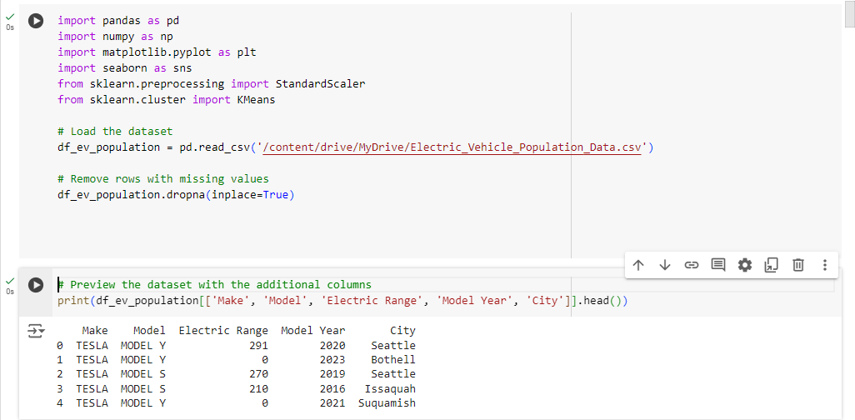

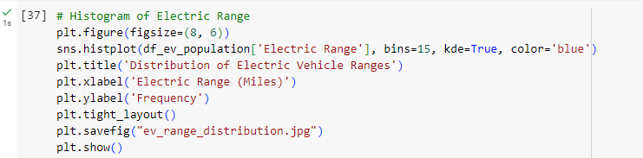

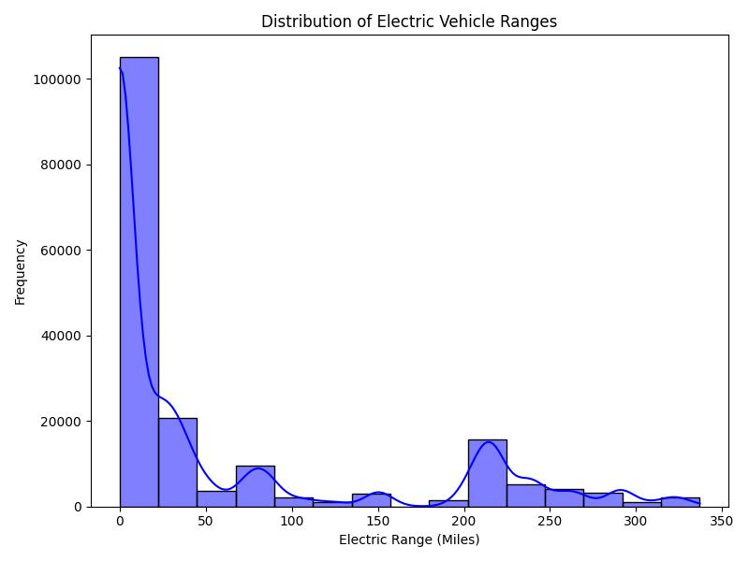

The histogram shows the distribution of electric vehicle ranges in a dataset. The x-axis represents the electric range in miles, and the y-axis represents the frequency of vehicles within each range. The bars indicate the number of vehicles in each range, and the curve provides a smoother representation of the distribution. This visualization helps to understand the typical range of electric vehicles in the dataset.

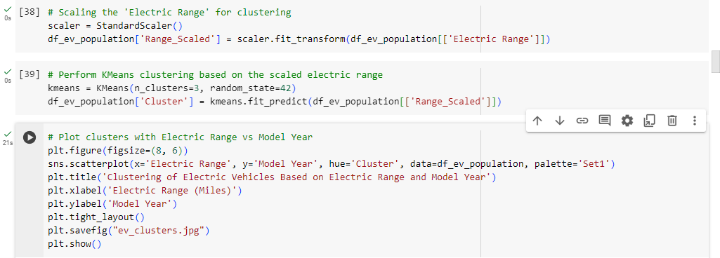

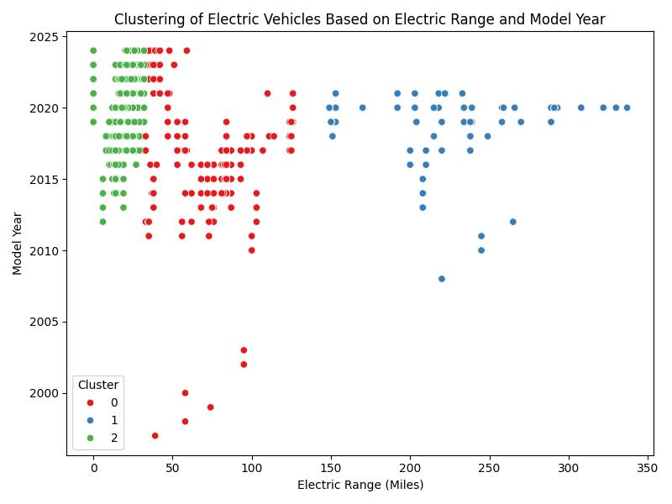

The scatterplot visualizes how electric vehicles are grouped based on their electric range and model year. The x-axis represents the electric range, and the y-axis represents the model year. The points are colored according to their cluster, showing the relationship between these two variables within each cluster.

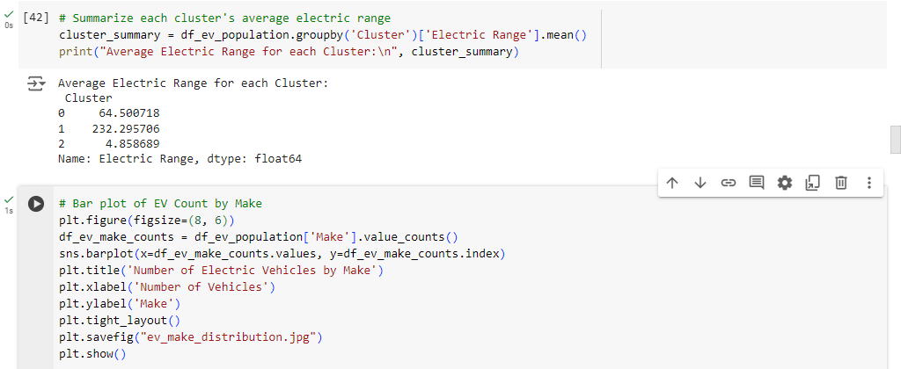

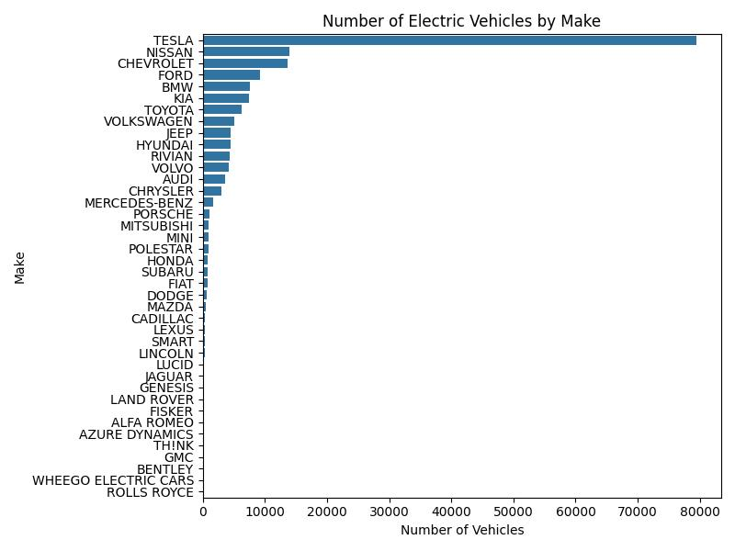

The bar graph shows how many electric vehicles there are from each car manufacturer (Make) in your data. The height of each bar represents the number of electric vehicles, and the labels on the bottom (y-axis) indicate the different car makes. This helps you see which manufacturers have the most electric vehicles in your dataset.

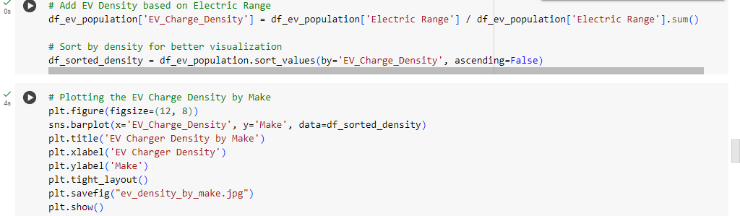

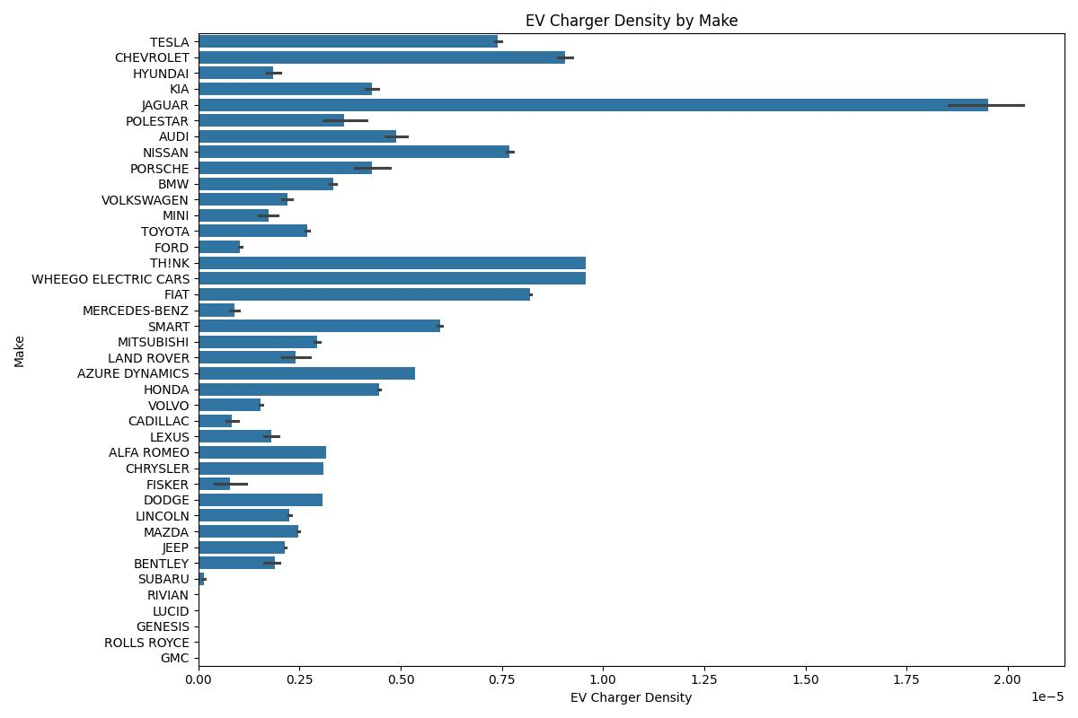

The bar graph shows the density of electric vehicle chargers for different car makers. The height of each bar represents the number of chargers per electric vehicle for that car maker, allowing for easy comparison of charger availability.

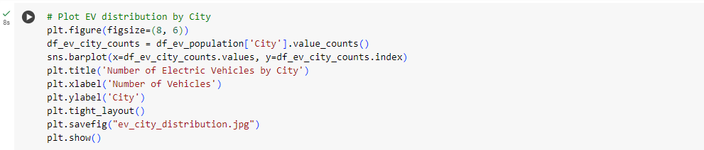

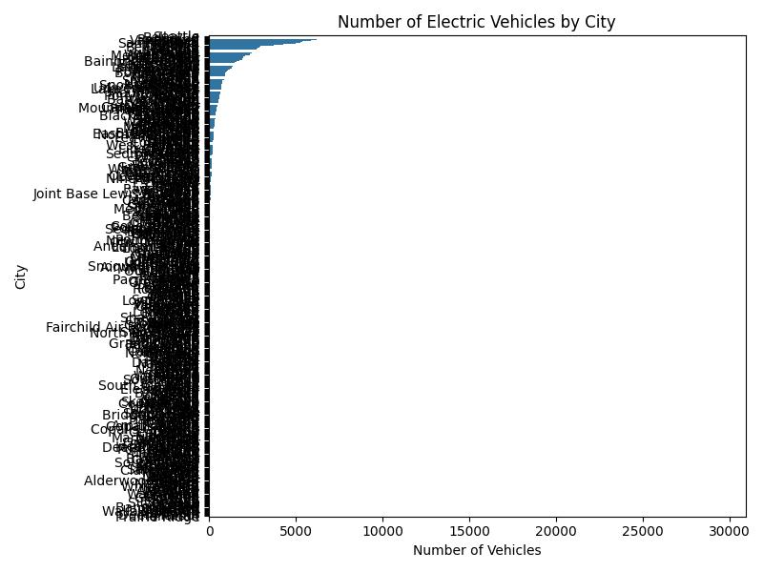

The bar graph shows the number of electric vehicles in different cities. The height of each bar represents the number of vehicles in a city, allowing for easy comparison of electric vehicle distribution across cities.

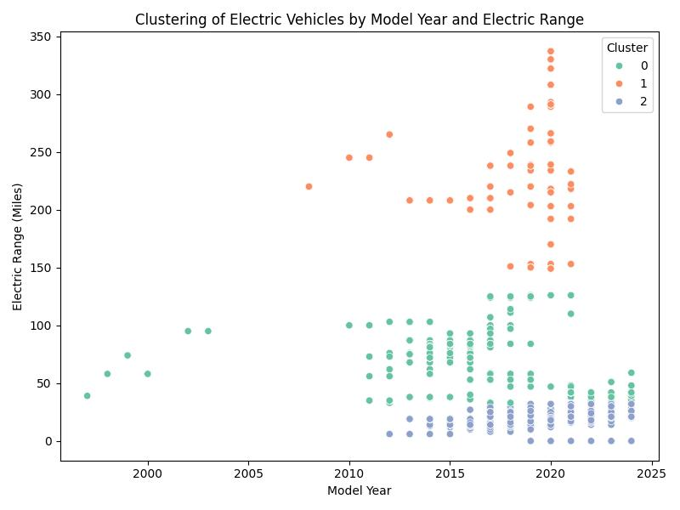

The scatterplot visualizes how electric vehicles are grouped based on their model year and electric range. The x-axis represents the model year, and the y-axis represents the electric range. The points are colored according to their cluster, showing the relationship between these two variables within each cluster.

This dataset explores the distribution and clustering of cars based on features such as price, make, city, model year, and model. After cleaning, the dataset is analyzed using KMeans clustering to group cars based on their prices, revealing three distinct price clusters. Visualizations include the distribution of car prices, car counts by make, and price density by make. Cars are also segmented into high, moderate, and low price categories. Additionally, insights are gained into the distribution of cars by city, and relationships between model year and price are explored through scatter plots. The analysis highlights price-driven patterns in car distribution across various cities and makes.

**Electric Vehicle (EV) Market in India**

**1.Introduction**

The Indian electric vehicle (EV) market is poised for significant growth, driven by environmental concerns, government initiatives, and advancements in technology. This report analyzes key segments within the market to identify opportunities for targeted strategies and entry points.

**2.Data Sources for Analysis**

* **NITI Aayog**: Insights into government policies, EV adoption forecasts, and market dynamics.
* **McKinsey and Deloitte Reports**: Analysis of consumer trends, technological innovations, and growth trajectories in the EV sector.

**Government Data**

* Ministry of Heavy Industries statistics on vehicle registrations, charging infrastructure development, and subsidy programs like FAME (Faster Adoption and Manufacturing of Hybrid and Electric Vehicles).

**Surveys and Studies**

* Consumer surveys conducted in key urban areas to capture attitudes towards EV adoption, preferred features, and barriers such as high upfront costs and charging station availability.

**3. Market Segmentation**

Focus on urban centers with the highest potential for EV adoption:

* **Delhi**: Severe pollution levels, government-backed EV subsidies, and extensive charging infrastructure.
* **Bengaluru**: High population of tech-savvy consumers and growing EV ecosystem.
* **Mumbai**: High vehicle density and increased awareness of environmental issues.

**Demographic Segmentation**

* **Age**: Young professionals aged 25-40 and families with higher disposable incomes.
* **Income Level**: Middle and upper-middle-class segments capable of absorbing higher upfront EV costs.
* **Education**: Higher-educated individuals who value technological advancements and eco-friendly solutions.

**Psychographic Segmentation**

* **Lifestyle**: Environmentally conscious and tech-oriented consumers.
* **Values**: Focus on reducing carbon footprints, saving on fuel costs, and driving innovation.

**Behavioral Segmentation**

* **Usage Patterns**: Daily commuters and long-distance travelers with distinct range requirements.
* **Brand Loyalty**: Consumers open to exploring new EV brands due to lack of established players in the segment.

**4.Data Analysis Techniques**

* **Descriptive Statistics**: To summarize adoption trends, consumer preferences, and regional EV penetration.
* **Clustering Analysis**: Segmenting consumers based on similar attributes like commuting frequency, range preferences, and willingness to pay.
* **Regression Analysis**: Identifying factors influencing EV adoption, such as price sensitivity, charging availability, and incentives.

**5.Profiling Market Segments**

**Demographic Profile**

* Consumers aged 25-40, predominantly urban professionals with mid-to-high income levels.

**Psychographic Profile**

* Tech-savvy individuals interested in sustainability and environmental preservation.

**Behavioral Insights**

* Daily urban commuters likely to adopt EVs for fuel savings and convenience.

**6.Target Segment Selection**

**Priority Segments**

* **Young Professionals in Metro Cities**: High likelihood of adoption due to eco-consciousness and access to charging infrastructure.
* **Corporate Fleets**: Businesses prioritizing sustainable transport solutions for delivery and commuting needs.

**7.Market Entry Strategy**

* **Pricing Strategy**: Leverage government subsidies and adopt penetration pricing for mass-market appeal.
* **Product Customization**: Develop models with varying battery ranges and smart features.
* **Infrastructure Partnerships**: Collaborate with charging station providers to improve accessibility.
* **Promotion**: Emphasize EV benefits through targeted digital marketing campaigns and influencer collaborations.

**8.Conclusion**

The Indian EV market presents a promising opportunity, particularly in metro cities with favorable policies and consumer openness to innovation. A data-driven approach to segmentation, combined with tailored marketing and strategic partnerships, can ensure successful market entry and sustained growth.

This analysis lays the foundation for developing a comprehensive strategy to tap into India's evolving EV market effectively.